DATE: 20.12.2019
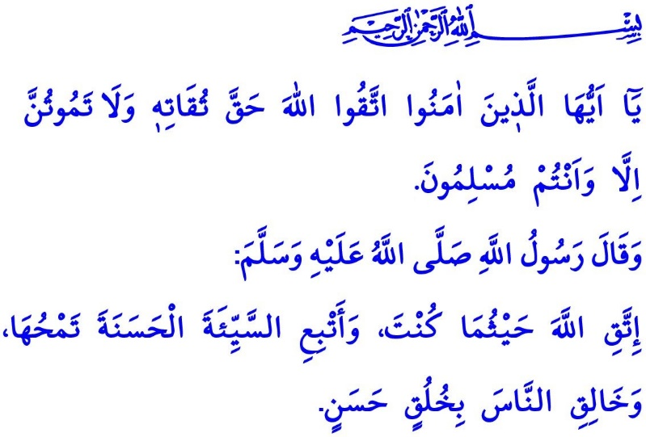
TAQWA: THE BEST PROVISION
Honorable Muslims!
The Prophet Muhammad (saw) had appointed one of his young companions Muadh ibn Jabal as ambassador to Yemen. He set out with him as he was going to bid farewell, and offered him some recommendations. Muadh was riding and the Prophet Muhammad (saw) was walking next to him. Before concluding his recommendations, the Prophet Muhammad (saw) said, “O Muadh! Perhaps you may not see me again next year, except visit this masjid or my grave.” Saddened because of having to be separated from the Prophet Muhammad (saw), Muadh started to cry upon those words. The Messenger of Allah (saw) turned facing Madinah and said, “The most superior people in my eyes, regardless of who they are and what status and authority they may have, are the ones who have taqwa.”
Dear Believers!
Taqwa is to live in the know of one’s material and spiritual responsibilities as a servant of Allah (swt). It is to obey His commandments and earn His approval. It is to turn away from those acts to earn His disapproval, and seek refuge in the shade of His mercy. It is to follow in the Prophet Muhammad’s (saw) footsteps, whom the Almighty Allah (swt) sent to us as the perfect role model and the unique guide.
Dear Muslims!
Only through taqwa is it possible for people to be honored with the divine mercy and protection. In the verse I have recited at the beginning of the khutbah, the Almighty Allah (swt) states, “O believers! Fear Allah as He should be feared and do not die except as Muslims in submission to Him.”
Proper taqwa takes people to always feel as if they are in the presence of Allah (swt), to not show a lack of respect for Him, and to obey Him with deep love. Taqwa, in this sense, is to be concerned about doing acts to earn Allah's (swt) wrath and appearing with a face down before Him. It is to make preparations in this world for the life in the Hereafter, as commanded by the verse, “O believers! Fear Allah. Let every soul look to what it has put forth for tomorrow.”

Dear Believers!
One day the Prophet Muhammad (saw) pointed his chest and repeated three times, “Taqwa is right here.” Taqwa is in the heart, right, but it is reflected on the body, in the words and behaviors. The comforting effect of taqwa manifests itself in our worships, good deeds, and good morals. Our awareness of taqwa is increased when we avoid what is evil and forbidden, and matures and reaches perfection through honesty and sincerity.
Taqwa is like the shield of Muslims. It is the shiver felt in the heart, the voice heard in the conscience. The barrier set up against the sins, and the bridge towards the merits... Then, Muslims who have taqwa thereby protect their hearts from sedition and corrupiton, their tongue from lies and slanders, and their eyes from what is forbidden. Their hands from unfairness, and their feet from racing for the evil... Let alone knowingly committing a sin, they do not even fall in two minds about going for things that may potentially lead to committing a sin. This is because a truly pious Muslim knows that observing the commandments and prohibitions of Allah (swt) will bring happiness in this world and salvation in the Hereafter.
Dear Muslims!
Taqwa is the only measure to determine our value in the sight of Allah (swt). This is because the superiority according to Islam does not depend on one's property, status and authority, profession, race, or gender. This is pointed out clearly in the verse, “The most noble of you in the sight of Allah is the most righteous of you.” The most virtuous of people are the ones who are honored with faith, have the clothing of taqwa on, a perfectly clean heart and a record of good deeds. These are the people with whom Allah (swt) is together. Their friend He is. For them are prepared the Paradise and all the unique blessings in it.
Dear Believers!
The Almighty Allah (swt) states, “Take provisions, but indeed, the best provision is taqwa. Fear Me, o you who understand.”
Then let us enrich our temporary life in this mortal world with taqwa. Let us continue to avoid evil and always be good and do good. Let us not frustrate our life in this world and in the Hereafter by trying to satisfy the insatiable desires of our nafs and by falling for the Satan’s deceit. Let us not forget that one day we will give account for every word out of our mouth and for every deed we do. I would like to conclude the khutbah with the following hadith of the Prophet Muhammad (saw), “Have taqwa of Allah wherever you are, and if you do evil knowingly or unknowingly, follow it with a good one to wipe the former out, and treat the people with good behavior.”

Ibn Hanbal, V, 236.
Al-i ‘Imran, 3/102.
Hashr, 59/18.
Ibn Hanbal, III, 134.
Hujurat, 49/13.
Nahl, 16:128; Jathiyah, 45/19; Ra’d, 13:35.
Baqarah, 2/197.
Tirmidhi, Birr, 55. General Directorate of Religious Services

